# Informações do estudo

Referência: Deshpande (treated)

Grandeza: Rugosidade

Tipo: Ra

Material: Inconel 718

Ferramenta: TNMG 160408 cryo treated

Número de experimentos: 20

Observações:  
Lathe machine: MTAB CNC  
Dynamometer: Kistler 9257B  
Workpiece: Ø 22 × 120 mm  
Surface roughness tester: Mitutoyo SURFTEST SJ-410

# Unidades

Velocidade: m/min

Avanço: mm/rev

Profundidade de corte: mm

Rugosidade: μm

# Dados de teste

|  |  |  |  |
| --- | --- | --- | --- |
| Rugosidade | n | f | a |
| 2.4 | 9.5 | 0.12 | 0.78 |
| 0.75 | 90.0 | 0.05 | 1.07 |
| 2.5 | 60.0 | 0.22 | 0.78 |
| 1.1 | 60.0 | 0.12 | 0.78 |

# Dados de treino

|  |  |  |  |
| --- | --- | --- | --- |
| Rugosidade | n | f | a |
| 1.21 | 90.0 | 0.18 | 0.5 |
| 2.3 | 30.0 | 0.18 | 1.07 |
| 1.0 | 60.0 | 0.01 | 0.78 |
| 1.6 | 30.0 | 0.05 | 1.07 |
| 0.98 | 60.0 | 0.12 | 0.78 |
| 0.76 | 90.0 | 0.05 | 0.5 |
| 0.99 | 60.0 | 0.12 | 0.78 |
| 1.79 | 90.0 | 0.18 | 1.07 |
| 1.17 | 60.0 | 0.12 | 0.78 |
| 1.1 | 60.0 | 0.12 | 0.78 |
| 2.2 | 30.0 | 0.18 | 0.5 |
| 1.35 | 60.0 | 0.12 | 0.3 |
| 0.95 | 60.0 | 0.12 | 0.78 |
| 0.6 | 110.45 | 0.12 | 0.78 |
| 1.8 | 60.0 | 0.12 | 1.26 |
| 1.36 | 30.0 | 0.05 | 0.5 |

# RN

Número de neurônios: 95

Taxa de aprendizado: 1.000000e-04

Número de épocas: 984

2° camada: True

Função de ativação: relu

# Erros

**Dados de teste**

* Erro relativo médio: 8.9
* Coeficiente de correlação: 1.0
* Coeficiente de determinação: 1.0
* MSE: 0.05
* RMSE: 0.22

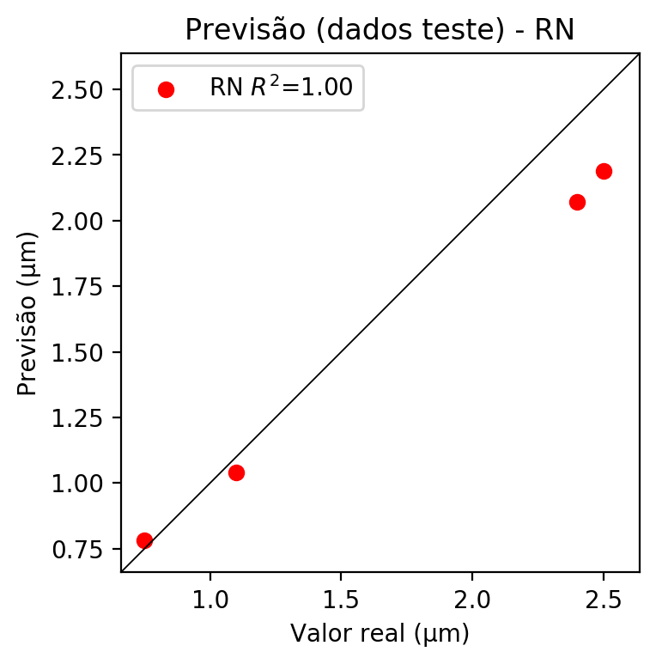

**Dados de treino**

* Erro relativo médio: 2.33
* Coeficiente de correlação: 1.0
* Coeficiente de determinação: 0.99
* MSE: 0.0
* RMSE: 0.0

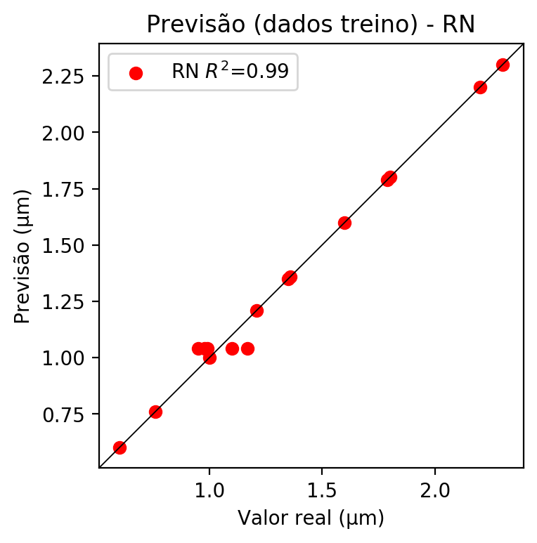

# Pesos

Pesos - camada oculta 1

[[ 0.1475006 0.07231692 -0.17797855 0.0048883 0.16128191 -0.12759206  
 -0.02402014 0.00054228 -0.08883996 0.09600902 -0.25277933 0.18104786  
 0.09806137 -0.01991974 -0.12261738 -0.1181963 0.04775446 -0.07000414  
 -0.22044036 0.22807834 0.22400305 0.1814765 -0.03681537 0.13478047  
 -0.06325626 -0.18896945 0.2576263 0.05153532 0.18605891 -0.18219054  
 -0.04212211 -0.26205218 -0.16744591 -0.20606549 0.01220664 -0.18454568  
 0.08409894 0.12648991 -0.20070395 -0.08195408 0.11644987 0.10908493  
 0.21176568 0.24838299 0.08356952 -0.03922851 0.02141467 -0.17469296  
 0.2259016 0.25842655 0.1406292 0.17391013 0.03909254 -0.04486959  
 -0.09703173 0.0361161 0.0404339 0.00887951 -0.24321294 -0.20620926  
 0.20387422 -0.21050231 -0.18817803 0.05593106 0.24794172 -0.24348655  
 -0.06316195 0.10439805 -0.20090999 -0.12717924 -0.06040835 0.00597413  
 -0.019772 -0.18840013 0.08629541 -0.15568362 0.08310463 0.21504886  
 0.01784295 -0.06913041 0.16209005 -0.2322021 -0.25119555 -0.05483071  
 -0.14831604 0.18311583 0.00863489 -0.21127774 -0.24009016 0.2168282  
 -0.09615324 -0.19528294 -0.2642764 0.04984133 -0.09410261]  
 [-0.160844 -0.24449104 0.06237492 0.11255281 -0.17612521 0.12531494  
 -0.10751146 0.23635556 -0.1632848 -0.19892798 -0.19794463 -0.06684542  
 -0.10073711 0.02315431 0.16899072 0.01020195 -0.14978397 0.2100094  
 0.22561769 0.06182663 0.22264227 0.01309581 -0.10149982 -0.06627253  
 -0.13625489 0.05961623 -0.18642117 0.03521276 -0.08854973 0.2620739  
 0.03442689 0.22580935 -0.04131167 -0.20099618 -0.05519178 0.14603323  
 -0.01640934 0.00394313 0.07716894 0.22569838 0.1458549 -0.10338575  
 0.06852622 -0.18574783 0.22082223 -0.11232746 -0.23101528 0.03188046  
 -0.06402427 -0.01971322 -0.07683539 0.19893005 0.14409804 0.19372152  
 0.06525836 0.24786179 -0.1880355 0.00347992 -0.14992742 -0.1729703  
 -0.2631304 0.19537899 0.20811231 0.1263442 -0.03869801 -0.14578512  
 0.17576915 -0.18771616 -0.04028079 -0.18857788 -0.2006188 0.192599  
 -0.09585724 -0.21064039 -0.09098727 -0.07688221 0.15873954 -0.22355764  
 0.18036743 -0.19958496 0.11830211 -0.24663967 0.17609292 0.05036248  
 -0.22403572 0.23850095 0.14587612 0.11695784 -0.08451176 -0.06134153  
 -0.10903827 0.22008254 0.22107448 -0.02298899 -0.09556584]  
 [-0.00184728 -0.16122776 -0.09237851 0.04547063 0.08850232 -0.06761038  
 0.18663606 0.130168 -0.10314158 -0.05201482 0.19185013 -0.22317097  
 0.24256685 0.06412998 -0.08021344 -0.0911529 -0.08121572 -0.0427917  
 -0.02556102 0.1801922 0.0258896 -0.08414965 -0.18138196 0.12275083  
 0.12058081 0.07334459 0.0900747 0.14401466 0.19705653 0.12360404  
 0.17663004 0.10270861 -0.07960552 0.15165432 0.16635792 -0.14503427  
 -0.04545273 -0.1260464 0.09233333 -0.19635767 -0.23708041 -0.11517097  
 -0.07399607 -0.21214111 0.22290018 0.11277684 -0.10438951 -0.06614022  
 0.2317397 -0.12628126 0.0783971 -0.06286298 0.10002252 -0.01488662  
 0.08620439 0.18678188 0.02197646 -0.01897532 0.04327681 0.04010848  
 0.13932864 -0.1395128 0.23187727 -0.14068295 0.10807936 0.13763505  
 0.2031746 0.06355089 0.12834166 -0.16493374 -0.18986534 0.22507115  
 -0.02042405 -0.1483251 -0.15796381 -0.01465939 -0.04678908 -0.11392603  
 -0.24111362 0.05884108 0.04999995 0.03929949 -0.20778897 -0.2642698  
 -0.06546939 0.03983889 0.07135282 -0.04820698 -0.11942774 -0.04334053  
 -0.00924056 0.21785067 -0.1660431 -0.15647112 0.04295676]]

Bias - camada oculta

[-9.96374711e-03 3.12356576e-02 2.64177710e-04 -8.54405109e-03  
 3.84270661e-02 5.51603250e-02 -4.29871521e-04 8.38309177e-04  
 2.70959344e-02 4.18066010e-02 -7.39586016e-04 3.56598049e-02  
 5.01319729e-02 -1.20931575e-02 3.20845662e-04 6.77947464e-05  
 -3.40428739e-03 7.84502656e-04 8.21393623e-04 1.73169877e-02  
 -1.66459754e-02 2.04012413e-02 2.75707804e-03 8.32955260e-03  
 -5.17624896e-04 2.32142881e-02 4.04108725e-02 9.39966412e-05  
 4.19585854e-02 9.51720169e-04 9.35215212e-05 1.00295180e-02  
 5.43558151e-02 -7.46975478e-04 4.42169560e-03 5.55323146e-04  
 3.26543301e-02 3.32204290e-02 -2.14254731e-04 4.28227186e-02  
 4.12652120e-02 -9.56843514e-03 4.57731001e-02 3.71695161e-02  
 7.54067732e-04 5.25860935e-02 3.42334472e-02 1.47566170e-04  
 5.09098470e-02 3.58610563e-02 -7.09506636e-03 4.12464328e-02  
 5.02993935e-04 7.16643233e-04 -7.30070565e-03 -1.42129501e-02  
 4.19557840e-02 -8.58166721e-03 2.95224693e-02 4.16401140e-02  
 -9.57646035e-03 6.70300797e-04 7.32402492e-04 2.58686375e-02  
 3.45515944e-02 2.55781151e-02 1.18839033e-02 4.21130285e-02  
 -8.97552818e-03 3.90304103e-02 -6.89253618e-04 9.99603435e-05  
 -6.03970257e-04 -7.22104334e-04 -9.70857032e-03 -1.05907042e-02  
 3.42279710e-02 3.21194977e-02 -7.92388711e-03 4.79594693e-02  
 -9.85412393e-04 -8.97165795e-04 6.63165760e-04 2.44400668e-04  
 -3.32786422e-03 -1.06840916e-02 -1.09697990e-02 -9.48349386e-03  
 -2.61104025e-04 2.64399536e-02 -3.83816799e-03 7.79812399e-04  
 -4.22456855e-04 -6.39607105e-03 4.75802384e-02]

Pesos - camada oculta 2

[[ 0.10480671 0.02193244 -0.10936487 ... -0.20635852 0.02651384  
 -0.05581155]  
 [-0.13081752 -0.18660422 0.05795374 ... 0.17134173 -0.03449645  
 -0.0550383 ]  
 [ 0.00767315 -0.09710642 -0.08180003 ... -0.13210104 -0.07856102  
 0.02139085]  
 ...  
 [ 0.04021353 0.13012044 0.03234029 ... 0.08333629 0.15473846  
 0.11393474]  
 [-0.18319775 -0.13108565 -0.07095483 ... -0.11308989 -0.03140862  
 0.12879501]  
 [-0.0497463 0.08376645 0.03169232 ... 0.17076859 0.0365279  
 0.01795073]]

Bias - camada oculta 2

[-0.03191939 0.0121169 0.03468285 -0.01226112 -0.00333898 0.02954737  
 0.03778812 -0.00463646 0.03005795 0.00058401 0.03238536 0.00535159  
 0.01310746 0.03269414 0.03066897 0.03783653 0.01748623 0.04048984  
 0.044092 -0.02523064 0.00954204 -0.01316592 0.03455283 -0.01114082  
 0.04316879 0.03047218 0.01313404 -0.00367845 -0.00567468 0.03306011  
 -0.00745184 -0.01124664 0.03371114 -0.00994659 0.00056727 0.04291822  
 0.00121405 -0.00439219 0.0290852 -0.00832598 0.00537426 -0.00201547  
 0.00847895 0.00742831 -0.01912807 0.03979643 -0.00194966 0.02740125  
 -0.0001097 -0.01025475 -0.00693828 0.00661057 0. 0.03038066  
 0.03221764 -0.00397381 0.0046805 0.00230297 0.04345042 -0.01145906  
 -0.00751733 0.03083724 0.03074575 0. -0.02011882 0.00376638  
 0.03167332 -0.01793664 0.03597165 0.0276153 0.04515225 0.  
 0.04412197 -0.00436944 0.00730457 0.03283435 -0.02487601 -0.02706086  
 -0.00353145 0.03928242 -0.03053753 -0.00942841 0.03818354 -0.01320347  
 0.03980084 -0.01956062 0.04262979 0.02868336 -0.00615348 0.00251648  
 0.03061048 0.03483014 0.03654423 -0.00990493 -0.01062496]

Pesos - camada saída

[[ 0.18934916 0.07175618 -0.19893384 0.04020251 0.14295691 -0.1547681  
 -0.0404335 0.01425374 -0.1037073 0.10386799 -0.28665355 0.17371565  
 0.10417788 -0.04380607 -0.13893425 -0.12821822 0.08906037 -0.09933913  
 -0.21598119 0.21073687 0.21475291 0.18985756 -0.07504347 0.15436253  
 -0.08116746 -0.20246197 0.2669775 0.05796843 0.18152809 -0.19951501  
 -0.03036821 -0.2417962 -0.18443552 -0.18590258 0.04924233 -0.2500112  
 0.0943793 0.11021112 -0.20819335 -0.04495963 0.15296887 0.11984843  
 0.23241852 0.25263852 0.1267108 -0.06596112 0.02175028 -0.18018918  
 0.23330075 0.27483952 0.17329499 0.17845213 0.05684704 -0.09113245  
 -0.13727638 0.06695028 0.0177769 0.04117973 -0.25871754 -0.21248156  
 0.2187693 -0.24013963 -0.2331778 0.06483459 0.23003766 -0.29948848  
 -0.0729593 0.10470768 -0.27629396 -0.16440901 -0.07151026 0.02674651  
 -0.03870327 -0.17814113 0.11743916 -0.19971004 0.07725769 0.22233823  
 0.05966492 -0.12578069 0.18805479 -0.23908645 -0.30698073 -0.02222342  
 -0.21453127 0.19906516 -0.02451249 -0.24236235 -0.23026226 0.1971042  
 -0.11211408 -0.18518193 -0.30867755 0.08048474 -0.10917071]]

# Iterações

|  |  |  |  |  |  |  |
| --- | --- | --- | --- | --- | --- | --- |
| Média | Desvio | n | ln | 2° camada | Função | Épocas |
| -0.3109 | 0.2261 | 10 | 0.1 | False | relu | 38 |
| -0.2257 | 0.1477 | 17 | 0.1 | True | relu | 716 |
| -0.2074 | 0.1444 | 7 | 0.01 | True | tanh | 130 |
| -0.8609 | 0.6324 | 19 | 0.001 | False | tanh | 282 |
| -0.2969 | 0.2511 | 29 | 0.001 | False | relu | 469 |
| -0.3378 | 0.2654 | 88 | 0.1 | False | tanh | 926 |
| -0.1689 | 0.1052 | 95 | 0.0001 | True | relu | 984 |
| -0.2217 | 0.1356 | 10 | 0.01 | True | tanh | 865 |
| -0.615 | 0.2523 | 58 | 0.001 | True | relu | 8 |
| -0.236 | 0.1243 | 9 | 0.01 | False | tanh | 514 |
| -0.3083 | 0.2105 | 73 | 0.0001 | True | relu | 729 |
| -0.1997 | 0.0981 | 22 | 0.001 | True | relu | 543 |
| -0.2019 | 0.1806 | 25 | 0.1 | True | relu | 562 |
| -0.3379 | 0.2953 | 53 | 0.001 | False | relu | 498 |
| -0.2093 | 0.2021 | 83 | 0.01 | True | relu | 337 |
| -1.1043 | 0.8853 | 99 | 0.01 | False | tanh | 16 |
| -0.2355 | 0.2412 | 23 | 0.01 | False | relu | 472 |
| -0.2275 | 0.1588 | 24 | 0.001 | True | relu | 778 |
| -0.3343 | 0.2025 | 58 | 0.01 | True | tanh | 382 |
| -0.5711 | 0.5576 | 35 | 0.1 | False | tanh | 596 |

# RL

# Coeficientes

[ 0. -0.56746075 0.49029961 0.17747072]

# Erros

**Dados de teste**

* Erro relativo médio: 15.57
* Coeficiente de correlação: 0.96
* Coeficiente de determinação: 0.91
* MSE: 0.13
* RMSE: 0.36

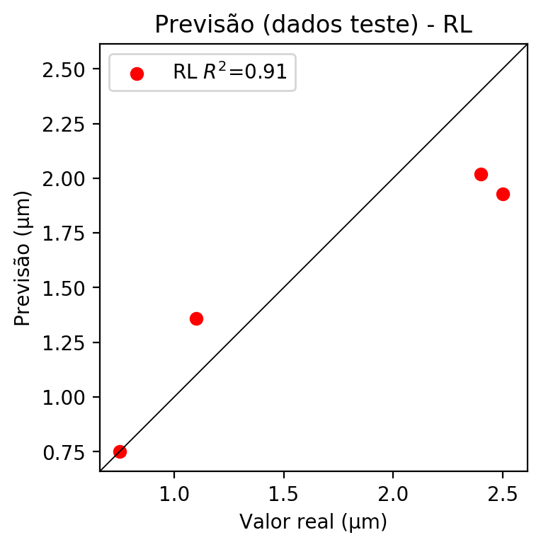

**Dados de treino**

* Erro relativo médio: 18.81
* Coeficiente de correlação: 0.86
* Coeficiente de determinação: 0.74
* MSE: 0.06
* RMSE: 0.24

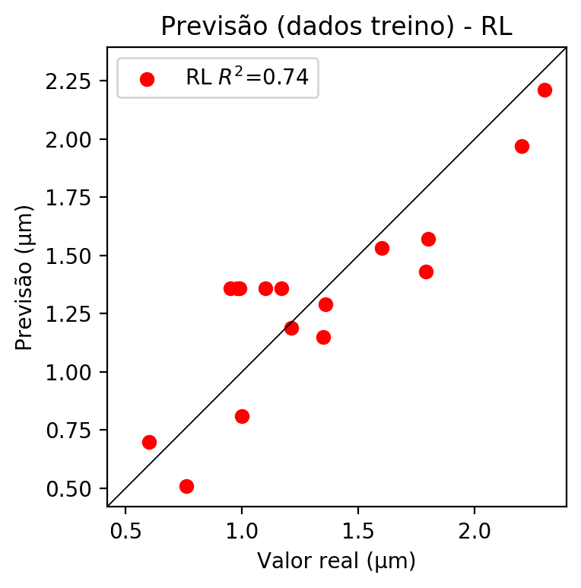

# RP2

# Coeficientes

[ 0. -0.48960326 0.50203595 0.21416486 0.07888768 -0.05984682  
 0.08811625 0.26905903 0.01651991 0.24606727]

# Erros

**Dados de teste**

* Erro relativo médio: 21.76
* Coeficiente de correlação: 0.94
* Coeficiente de determinação: 0.89
* MSE: 0.14
* RMSE: 0.37

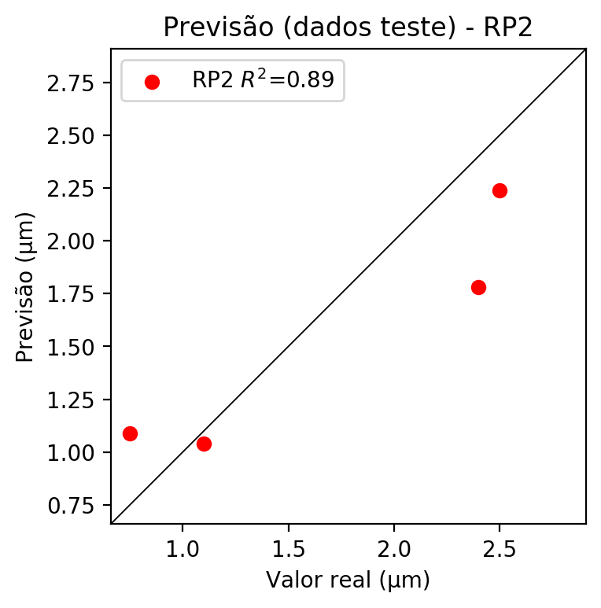

**Dados de treino**

* Erro relativo médio: 5.2
* Coeficiente de correlação: 0.99
* Coeficiente de determinação: 0.98
* MSE: 0.0
* RMSE: 0.0

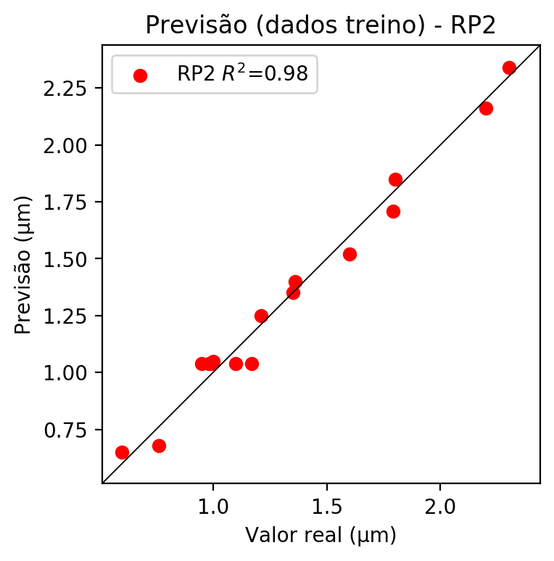

# RP3

# Coeficientes

[ 1.31838984e-16 -7.63296710e-02 7.69496522e-02 2.70535061e-02  
 1.47079911e-01 -2.43527867e-02 5.19767760e-02 1.97840003e-01  
 5.28612722e-02 2.34544358e-01 -1.50828868e-01 1.16003974e-01  
 3.48098899e-02 -8.29580059e-02 8.09168026e-02 -8.16515499e-02  
 9.11471796e-02 3.50453085e-02 1.15713005e-01 4.27816098e-02]

# Erros

**Dados de teste**

* Erro relativo médio: 12.53
* Coeficiente de correlação: 0.99
* Coeficiente de determinação: 0.98
* MSE: 0.08
* RMSE: 0.28

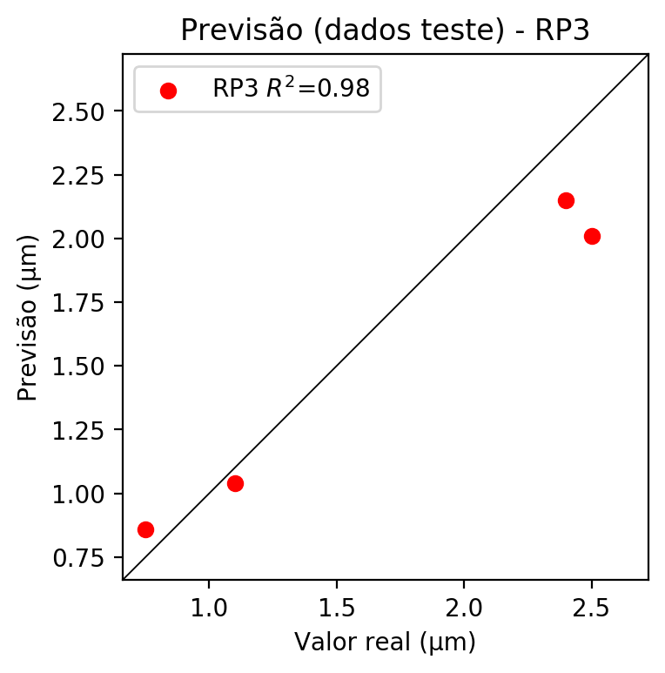

**Dados de treino**

* Erro relativo médio: 2.33
* Coeficiente de correlação: 1.0
* Coeficiente de determinação: 0.99
* MSE: 0.0
* RMSE: 0.0

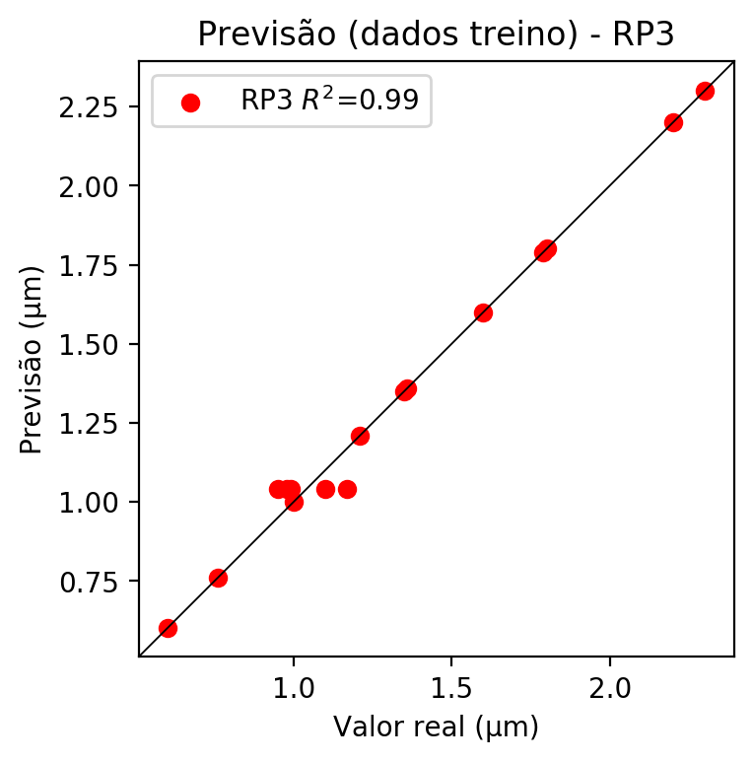

# RP4

# Coeficientes

[ 1.38777878e-17 -6.35413259e-02 6.55657081e-02 3.88569166e-02  
 4.20448448e-02 -1.40744197e-02 1.80821871e-02 5.14726330e-02  
 -2.61273631e-03 5.21191955e-02 -1.14468462e-01 8.26427056e-02  
 6.18243192e-02 -7.53044060e-02 2.03553807e-02 -7.40761034e-02  
 1.05990059e-01 6.29479618e-02 8.26093743e-02 3.98895568e-02  
 6.66483402e-03 -1.94631203e-02 2.51554621e-02 8.77522358e-02  
 -3.65990147e-03 8.68313958e-02 -1.94248565e-02 2.54526423e-02  
 -1.96192418e-02 2.51193930e-02 4.55832743e-02 -4.18575567e-03  
 8.77950862e-02 -3.54942377e-03 4.63039473e-02]

# Erros

**Dados de teste**

* Erro relativo médio: 30.32
* Coeficiente de correlação: 0.89
* Coeficiente de determinação: 0.79
* MSE: 0.21
* RMSE: 0.46

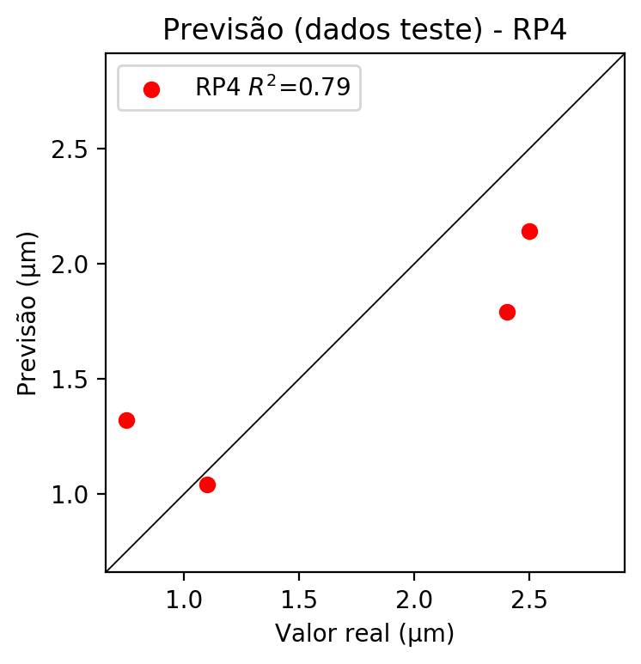

**Dados de treino**

* Erro relativo médio: 2.33
* Coeficiente de correlação: 1.0
* Coeficiente de determinação: 0.99
* MSE: 0.0
* RMSE: 0.0

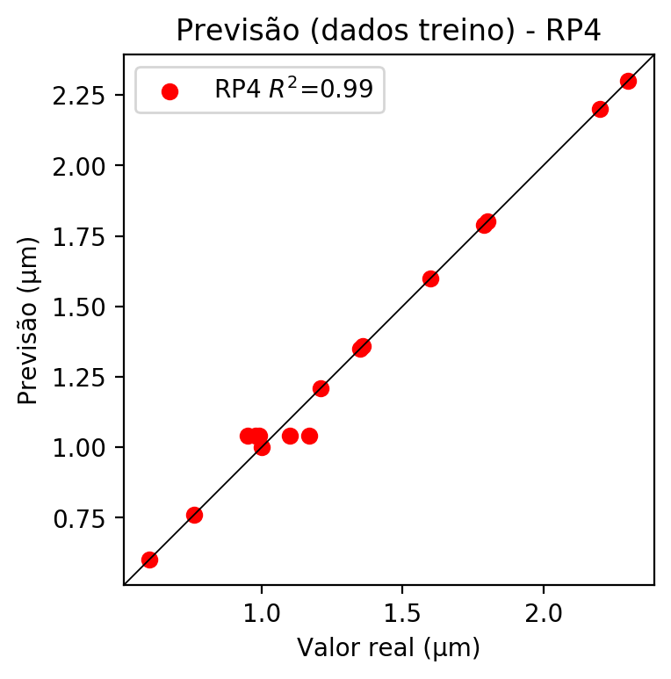

# Geral

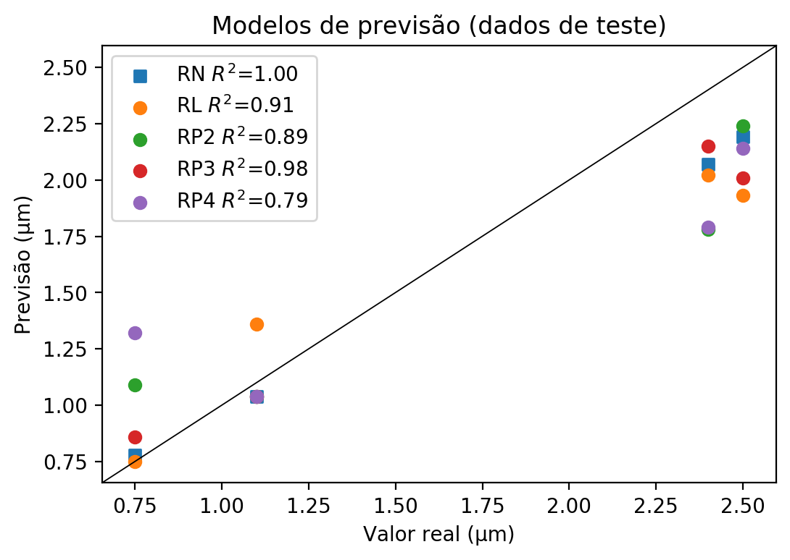

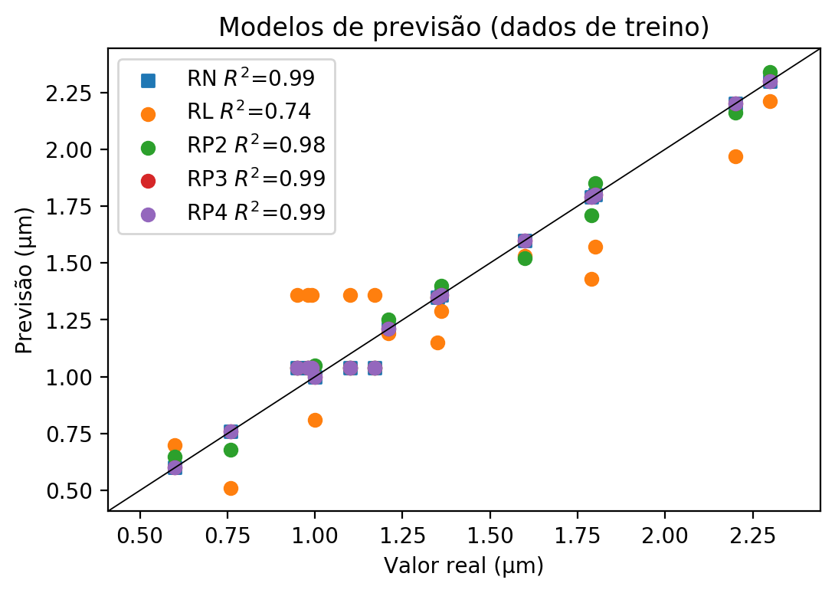

**Dados de teste**

|  |  |  |  |  |  |  |  |  |  |  |
| --- | --- | --- | --- | --- | --- | --- | --- | --- | --- | --- |
| Valor real | RN Previsto | RN Erro (%) | RL Previsto | RL Erro (%) | RP2 Previsto | RP2 Erro (%) | RP3 Previsto | RP3 Erro (%) | RP4 Previsto | RP4 Erro (%) |
| 2.4 | 2.07 | 13.75 | 2.02 | 15.83 | 1.78 | 25.83 | 2.15 | 10.42 | 1.79 | 25.42 |
| 0.75 | 0.78 | 4.0 | 0.75 | 0.0 | 1.09 | 45.33 | 0.86 | 14.67 | 1.32 | 76.0 |
| 2.5 | 2.19 | 12.4 | 1.93 | 22.8 | 2.24 | 10.4 | 2.01 | 19.6 | 2.14 | 14.4 |
| 1.1 | 1.04 | 5.45 | 1.36 | 23.64 | 1.04 | 5.45 | 1.04 | 5.45 | 1.04 | 5.45 |

**Dados de treino**

|  |  |  |  |  |  |  |  |  |  |  |
| --- | --- | --- | --- | --- | --- | --- | --- | --- | --- | --- |
| Valor real | RN Previsto | RN Erro (%) | RL Previsto | RL Erro (%) | RP2 Previsto | RP2 Erro (%) | RP3 Previsto | RP3 Erro (%) | RP4 Previsto | RP4 Erro (%) |
| 1.21 | 1.21 | 0.0 | 1.19 | 1.65 | 1.25 | 3.31 | 1.21 | 0.0 | 1.21 | 0.0 |
| 2.3 | 2.3 | 0.0 | 2.21 | 3.91 | 2.34 | 1.74 | 2.3 | 0.0 | 2.3 | 0.0 |
| 1.0 | 1.0 | 0.0 | 0.81 | 19.0 | 1.05 | 5.0 | 1.0 | 0.0 | 1.0 | 0.0 |
| 1.6 | 1.6 | 0.0 | 1.53 | 4.38 | 1.52 | 5.0 | 1.6 | 0.0 | 1.6 | 0.0 |
| 0.98 | 1.04 | 6.12 | 1.36 | 38.78 | 1.04 | 6.12 | 1.04 | 6.12 | 1.04 | 6.12 |
| 0.76 | 0.76 | 0.0 | 0.51 | 32.89 | 0.68 | 10.53 | 0.76 | 0.0 | 0.76 | 0.0 |
| 0.99 | 1.04 | 5.05 | 1.36 | 37.37 | 1.04 | 5.05 | 1.04 | 5.05 | 1.04 | 5.05 |
| 1.79 | 1.79 | 0.0 | 1.43 | 20.11 | 1.71 | 4.47 | 1.79 | 0.0 | 1.79 | 0.0 |
| 1.17 | 1.04 | 11.11 | 1.36 | 16.24 | 1.04 | 11.11 | 1.04 | 11.11 | 1.04 | 11.11 |
| 1.1 | 1.04 | 5.45 | 1.36 | 23.64 | 1.04 | 5.45 | 1.04 | 5.45 | 1.04 | 5.45 |
| 2.2 | 2.2 | 0.0 | 1.97 | 10.45 | 2.16 | 1.82 | 2.2 | 0.0 | 2.2 | 0.0 |
| 1.35 | 1.35 | 0.0 | 1.15 | 14.81 | 1.35 | 0.0 | 1.35 | 0.0 | 1.35 | 0.0 |
| 0.95 | 1.04 | 9.47 | 1.36 | 43.16 | 1.04 | 9.47 | 1.04 | 9.47 | 1.04 | 9.47 |
| 0.6 | 0.6 | 0.0 | 0.7 | 16.67 | 0.65 | 8.33 | 0.6 | 0.0 | 0.6 | 0.0 |
| 1.8 | 1.8 | 0.0 | 1.57 | 12.78 | 1.85 | 2.78 | 1.8 | 0.0 | 1.8 | 0.0 |
| 1.36 | 1.36 | 0.0 | 1.29 | 5.15 | 1.4 | 2.94 | 1.36 | 0.0 | 1.36 | 0.0 |